Phase 4 – Salesforce Expense Report Multi-Level Approval Process

Name: Shaik Javeed Ahammad

1.Introduction Phase 3 introduced the foundation of the approval process by handling automatic approvals for smaller expenses and routing larger ones to managers. However, in a real-world corporate environment, the approval process is rarely limited to just one level. Large organizations require multi-layer approval structures to ensure financial accountability, compliance with company policies, and protection against fraudulent claims.

Phase 4 addresses this by extending the approval mechanism into a multi-level process that escalates approvals based on the amount submitted. It also introduces notifications, validation rules, and analytics dashboards to improve user experience and reporting. This makes the system robust, scalable, and aligned with enterprise-level expense management needs.

2. Objectives

• To create a multi-tier approval chain that handles expenses based on value thresholds.

• To implement automatic notifications for both employees and approvers at every stage.

• To enforce policy compliance by introducing mandatory receipt uploads.

• To provide real-time monitoring through reports and dashboards.

• To reduce administrative delays by ensuring that expense reports are routed to the correct level without manual intervention.

3. Scope This phase focuses on four major enhancements:

1. Multi-level approval process configuration.

2. Email alerts and notifications for status tracking.

3. Validation rules to enforce company policies.

4. Reports and dashboards for improved financial visibility.

4. Approval Hierarchy In Phase 4, we introduce a tiered approval mechanism:

• Level 1 (Auto Approval): Any expense report with Amount__c ≤ 500 is automatically approved by the system without requiring human intervention.

• Level 2 (Manager Approval): Expense reports where 500 < Amount__c ≤ 5000 are routed to the Manager role for review.

• Level 3 (Director Approval): Expense reports where 5000 < Amount__c ≤ 20000 are routed to the Director for review and approval.

• Level 4 (CFO/Finance Approval): High-value expense reports where Amount__c > 20000 are routed to the CFO or Finance Head, ensuring financial oversight at the highest level.

This structured hierarchy ensures that small expenses are processed quickly while large expenses undergo rigorous review.

5. Implementation Steps

Step 1 – Extend Flow with Multi-Level Approvals The Phase 3 flow is enhanced to include additional Decision branches:

• Auto Approval → If Amount ≤ 500 → Update record to Approved.

• Manager Approval → If 500 < Amount ≤ 5000 → Submit for Manager Approval.

• Director Approval → If 5000 < Amount ≤ 20000 → Submit for Director Approval.

• CFO Approval → If Amount > 20000 → Submit for CFO Approval.

Each branch is connected to its own Submit for Approval Action that references the appropriate Approval Process.

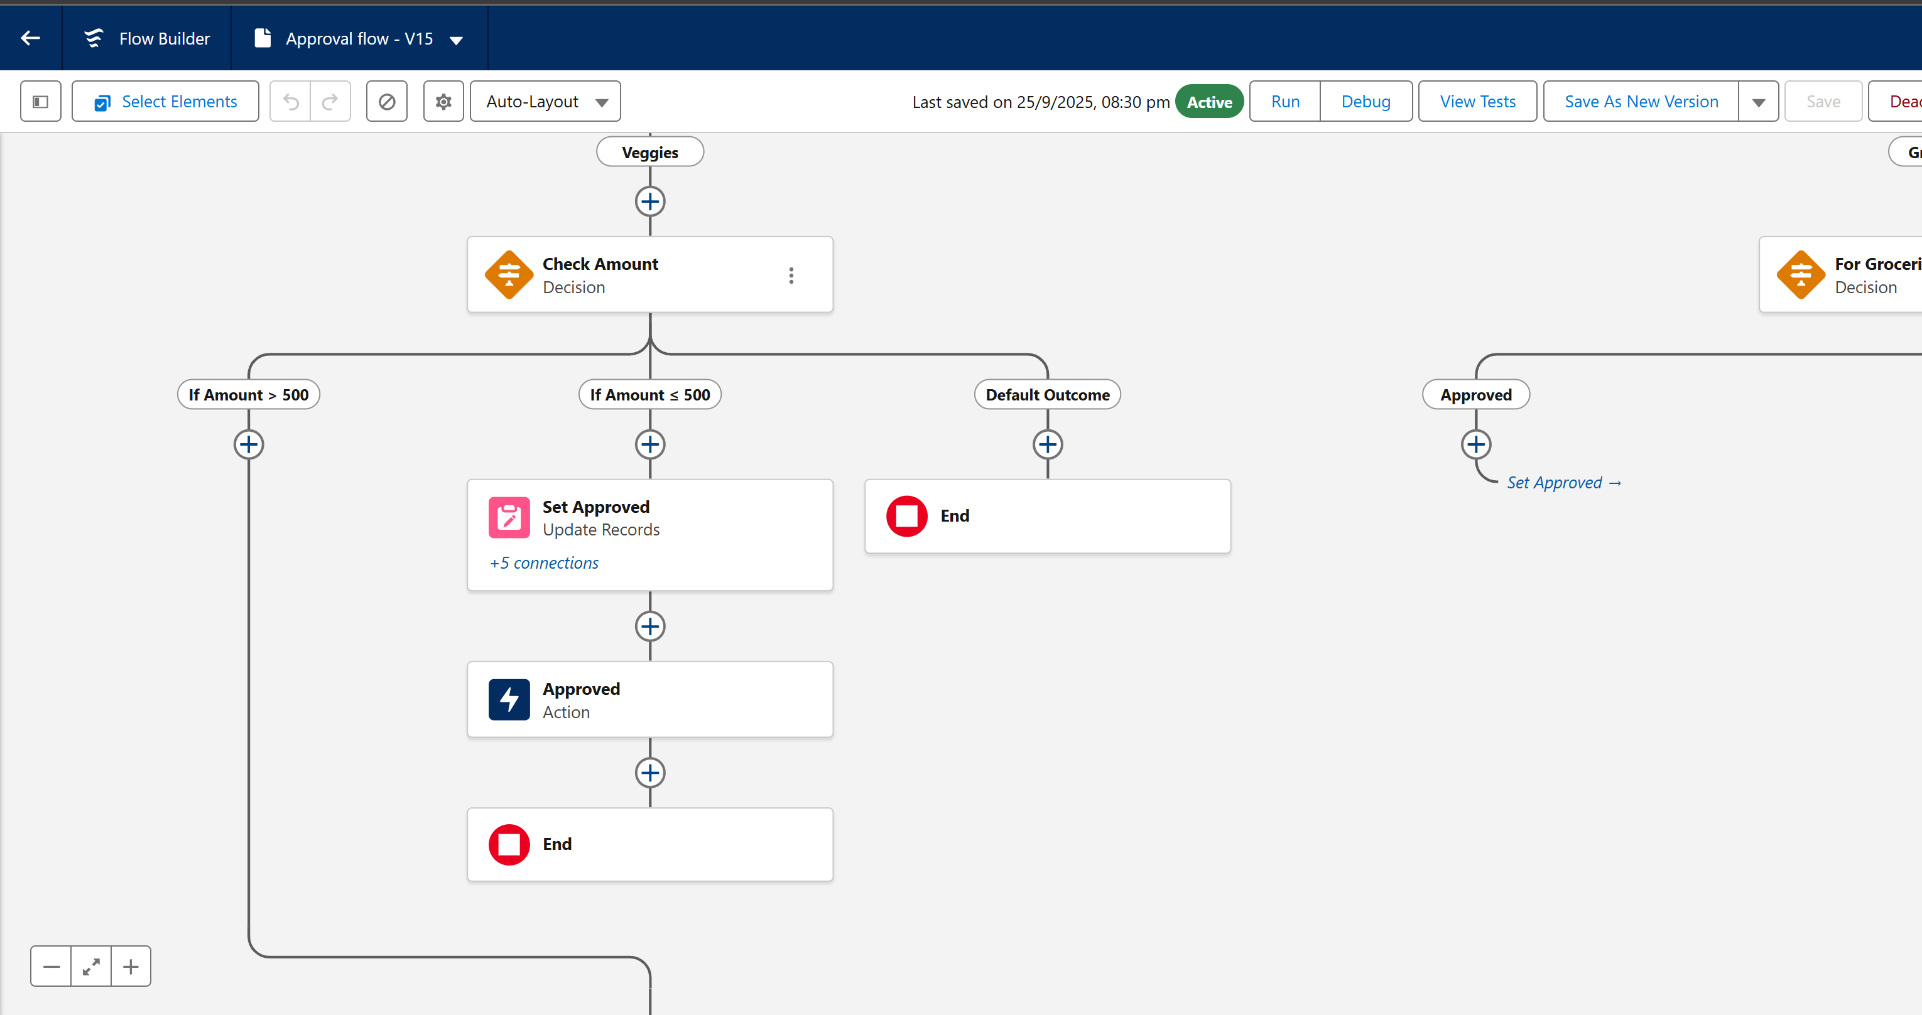

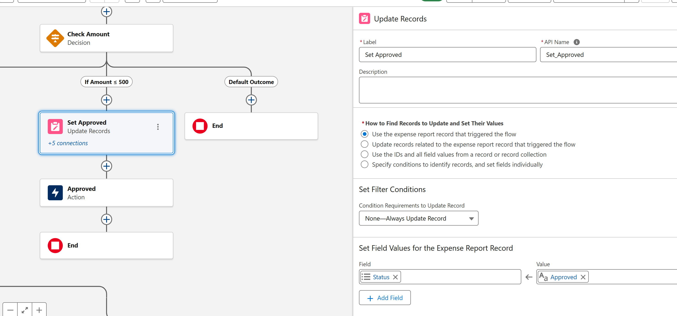

Step 2 – Create/Modify Approval Processes Approval processes are created for each approver role. Each process contains:

• An entry criteria (based on amount range).

• An assigned approver (Manager, Director, CFO).

• Actions upon approval (status = Approved).

• Actions upon rejection (status = Rejected).

These processes ensure that each request follows the appropriate approval path.

Step 3 – Configure Email Notifications

Communication is a critical part of any approval system. Email alerts are configured for the following:

• When an employee submits an expense report → Notification confirming submission.

• When a request is assigned to an approver → Notification sent to the approver.

• When a report is approved/rejected → Notification sent back to the employee.

• Optional reminder notifications can also be configured for pending approvals after a defined time frame.

Step 4 – Add Validation Rules

To ensure compliance, validation rules are added.

For example:

1. Receipt Required:

2. AND( Amount__c > 500, ISBLANK(Receipt__c) )

→ Ensures that any expense above 500 must have a receipt attached.

3. Valid Status Submission:

Ensures that expense reports can only be submitted if the Status__c field is set to "Submitted".

These rules reduce the risk of incomplete or non-compliant expense submissions.

Step 5 – Reports and Dashboards

To provide visibility into the process, several reports are created:

• Expense Reports by Status → Tracks how many reports are Approved, Pending, or Rejected.

• Expenses by Amount Range → Segments expenses into categories (20000).

• Pending Approvals by Approver → Helps managers and directors monitor their workload. These reports are added to a dashboard for executives, giving them a consolidated view of expense management in real-time.

6. Testing Plan The process is tested through a series of cases:

• Case 1 (Auto Approval): Submit an expense of 300. Expected result → Auto approved instantly.

•Case 2 (Manager Approval): Submit an expense of 1500. Expected result → Routed to Manager, employee notified.

• Case 3 (Director Approval): Submit an expense of 8000. Expected result → Routed to Director, approval history updated.

• Case 4 (CFO Approval): Submit an expense of 25,000. Expected result → Routed to CFO, no bypass possible.

• Case 5 (Validation Rule): Submit 2000 without attaching a receipt. Expected result → Error message displayed, record not submitted.

All test results are logged and verified against expected outcomes.

7. Outcomes

• Expense approval process now supports complex, multi-level decision-making.

• Employees are kept informed at every step through notifications.

• Approvers have visibility into pending requests and can act quickly.

• Validation rules ensure compliance and data accuracy.

• Reports and dashboards give executives a clear picture of organizational spending.

This phase significantly improves the efficiency and reliability of the system, making it enterprise-ready